**PLASMA DONOR APPLICATION**



**Team ID:PNT2022TMID48261**

**Faculty mentor: Team leadA.ANUSUDHA**

**M.Naseem banu Team member: Jeeva**

**Team member: Sopitha**

**Team member:K.Kaviya**

**Proposed solution**

Conventionally, when a patient needs blood, he/she has to contact a blood bank or a compatible blood group of a donor in their circle, family, and friends. However, it is difficult to find suitable donor within a limited group of people in a given time. In addition, there is no guarantee that blood banks will have compatible blood group in stock. There is also steady increase in blood donation requests posts in social networking sites (like Facebook, twitter, Instagram, etc.) requesting for donation.

Ease of access, requirements of blood, and the blood donation statistics are taken into consideration while researching the topic. There is a steady need for blood and blood components (red blood cells, blood plasma, platelets). Every minute of every day someone is in need for blood, however as e.g., in Canada , only 1 in 60 Canadians gave blood last year, when almost 1 of every 2 Canadians is eligible to donate. 52% of Canadians say they or a family member have needed blood or blood products. The blood donation rate in high-income countries is 33.1 donations per 1,000 people; 11.7 donations in middle-income countries and 4.6 donations in low-income countries. As a result, finding blood donor is becoming very difficult in almost every country.There are some blood donor finder applications such as Blood app by Red Cross which allows the donor to book appointment with blood banks and also can find local blood drives and donation centers quickly and easily. However, there is no direct communication between the donor and that clinic in need of a specific blood type. As a result, this app is more beneficial for donors but not for clinics to find needed blood type directly and promptly. Blood Donor Finder application by Neologix allows users in need for blood to find nearest donors. Although this application helps finding donors, but the ease of communication with those donors is not prompt and it requires man power as the requester (patient or clinic) has to contact each donor individually. Also, there is no application that provides a proper communication channel to notify donors about the blood donation requirements.

**Idea of blood donor system**

**Abstract**

With rapid increase in the usage of social networks sites across the world, there is also a steady increase in blood donation requests as being noticed in the number of posts on these sites such as Facebook and twitter seeking blood donors. Finding blood donor is a challenging issue in almost every country. There are some blood donor finder applications in the market such as Blood app by Red Cross and Blood Donor Finder application by Neologix. However, more reliable applications that meet the needs of users are prompted. BLOOD application can resolve these issues by connecting patients promptly with a large pool of donors in the same region via an authorized clinic. When a patient needs a blood donation, the clinic (where the patient is admitted) can use the application to contact the blood donors in the vicinity or nearby city based on their location. The registered donors will get notification about the blood donation needed at a specific clinic where they can go and donate. The major contribution of Human Sciences in the understanding of the whole blood donation behavior has been through the study of individuals’ motivations and deterrents to donate. However, if whole blood donation has been very widely studied in the last sixty years, we still know very little about plasma donation in voluntary non-remunerated environments. Yet, the need for plasma-derived products has been strongly increasing for some years, and blood collection agencies have to adapt if they want to meet this demand. This article aims to review the main motivations and deterrents to whole blood donation, and to compare them with those that we already know concerning plasma donation. Current evidence shows similarities between both behaviors, but also differences that indicate a need for further research regarding plasma donation.

**Introduction**

Cloud computing is nothing but internet based computing which made revolution in today’s world. It is the biggest innovation which uses advanced computational power and improves data sharing and data storing capabilities. Cloud is a large group of interconnected computers, which is a major change in how we store information and run application. Cloud computing is a shared pool of configurable computing resources, on demand network access and provisioned by the service provider. The advantage of cloud is cost savings. The prime disadvantage is security. The cloud computing security contains to a set of policies, technology controls deployed to protect data, application the associated infrastructure of cloud computing. Blood Donation System is an android based system that is designed to store, process, retrieve and analyse information concerned with the administrative and inventory management within a blood bank. This project aims at maintaining all the information pertaining to blood donors, different blood groups available in each blood bank and helps them to manage in a better way. Aim is to provide transparency in this field, make the process of obtaining blood from a blood bank hassle free and corruption free and make the system of blood bank management effective document is a template.

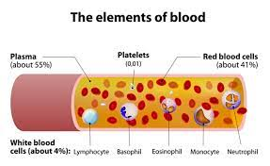

**Methodology**

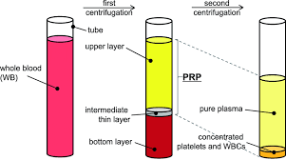

Blood Bank Management System is a web based system with integrating SMS alert function that implemented using HTML, PHP, CSS, JavaScript and JQuery for web development and MySQL for database design. Blood donor can register on the system and it will provide with a donor an ID. Blood campaign organizers can organize a campaign through online. The request is sent to the particular blood bank officer and officer can approve or reject the request. Once he/she approves the campaign, donors may get SMS notification to their mobile by informing the campaign. Not only that, organizer informs with the approved status via SMS to the organizer’s phone. Patients can request blood via online or just by sending a SMS to the system. Then system will inform to all the relevant donors with the request. Blood stock will be handled day by day through the system. Blood bank officer can add or remove a donor to the system and from the system. Also he can add blood stock to the relevant blood bank. Blood Bank Management system has separate Admin panel. Administrator can view island wide blood stock either as blood group or branch. Furthermore, administrator can add a new bank to the system as well as a user to the system.

**Analysis**

In this system, users can search donors and make request for blood. Donors can login to their own profiles and update information.They can search donor, request for blood and send message to other donors. Admin can maintain system management tasks. The use case diagram and class diagram of the system are shown in the Figure respectively.

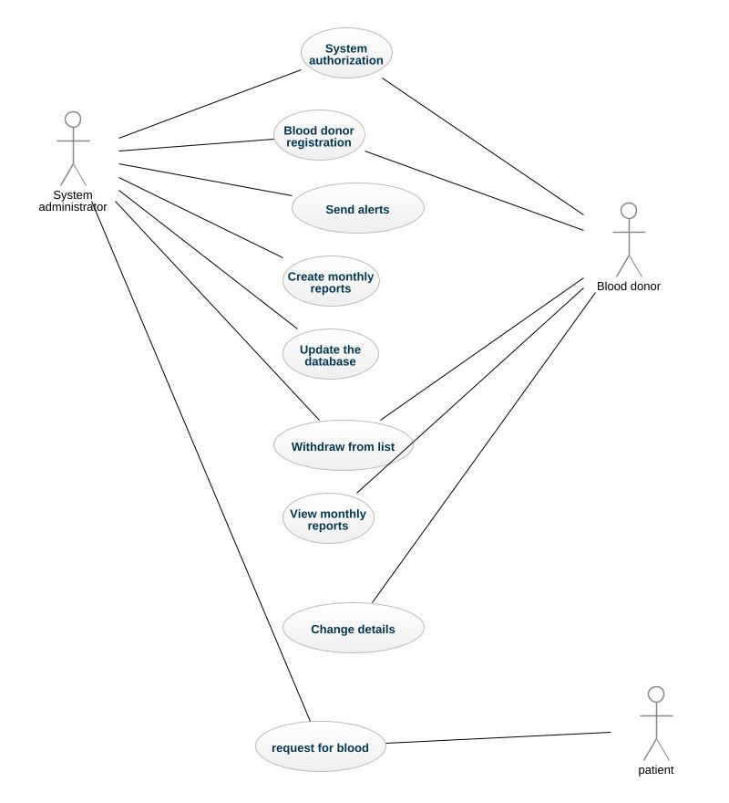

Usecase diagram of the system

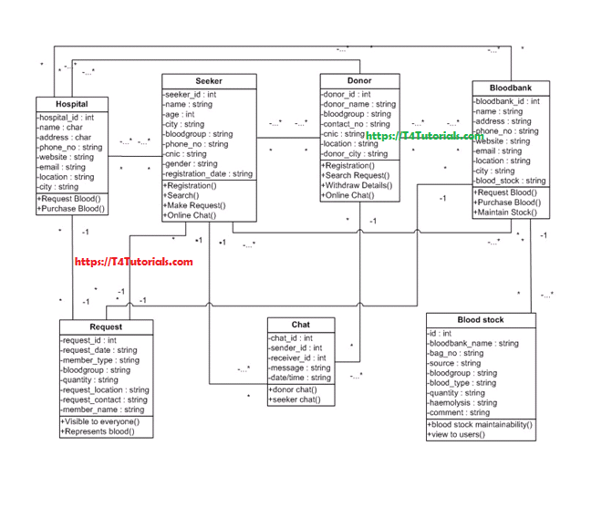

**Class diagram of the system**

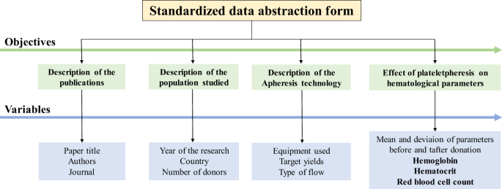

**Database design of the system**

**A Study on Automation of Blood DonoClassification**

**and Notification Techniques**

**Abstract**

The increasing demand for sophisticated, intelligent systems in the field of healthcare leads to a need for introduction of automation of processes. The area of transfusion medicine, specifically blood donation services require this implementation at the earliest. The present situation is one where most processes in blood donation services are manual and the demand for blood is constantly on the rise, augmented by declining donation rates. Hence, an intelligent system that can integrate major operations involved, make efficient decisions, improve communication and introduce significant agility is highly crucial. A system of this sort would involve a uniform labelling standard for blood packet identification, machine learning algorithms for efficient donor selection and a notification system.

**Introduction**

The requirement for blood is steadily increasing as a result of increasing population and also, advancement in clinical medicine. On the contrary, the number of voluntary donors is decreasing over the last few years. Recent findings bring to light the fact that a majority of the new donors fail to donate a second time. It is not economically viable to continually check for donors who fail to return for a subsequent donation.

Retention of donors who pass the initial health checks is vital to the strategy of increasing

increasing blood donation. However, blood donation services can alter their strategies to rope in donors only if they can understand the factors that influence their donation

behaviour. Finding and understanding these factors would help the blood donation services to come up with newer and more efficient strategies that would increase the return rate of donors . An analysis conducted in shows that the factors

influencing the decision to donate blood are complex.

**Overall study**

The process of record keeping in hospitals, which is now mostly manual and error-prone, becomes simpler, more efficient and with a reduced monitor-replenish cycle by a Markov chain implementation A simple M/M/I/k queueing model is

utilized to study the suitable rate of acquisition as a function of consumption, minimum amount which is required and the maximum available storage capacity. This model applies for a single component of blood, for each component a separate model must be devised. Different thresholds and activation of notification of system based on its values.

M M Mostafa conducts a research analysis and tries to profile blood donors for optimized recruitment Blood banks and transfusion centres depend entirely on

volunteer blood donors but it is shown that it is a challenge to find considerable number of volunteers. Research conducted attempts to identify factors that discriminate donors from non-donors. Conclusion is drawn from various psychological, conceptual, behavioural and related literature, hypotheses supporting correlations between said factors and blood donation tendencies.

**Proposed solution**

It suggests a new mathematical model that is not as restrictive as the ones proposed in , referred to as the Simple Linear assignment. The simple linear assignment algorithm schedules requests immediately, does not allow cross match for

blood types and is used as the benchmark. The optimization problem is modelled into a multiple knapsack solution where it is experimented to see whether cross matching compatible blood types in order to satisfy blood requests can be used to stabilize the proportion of blood type usage

within the blood bank as well as minimize scenarios where blood has to be imported. The model is elaborated with constraints on blood compatibility and blood types assigned values based on how many blood types it is compatible with.

Results and conclusions show that the multiple knapsack solution fares better than the simple assignment solution in reducing the number of units that is to be imported. There were a few negative side effects where the MKA used more of the most valuable blood type (O-) due to it getting substituted in cross matching of compatible blood types. This efficient model for managing and distribution of blood utilizes various optimization strategies to show that optimization is possible with cross matching. Risk assessment in medical datasets demands two factors- the probability of

an event occurring and a measure of impact severity by the occurrence of the event. This is satisfied with a BN implementation. A case study on risk calculation from real time data collected from End Stage Renal Disease patients shows that different sources of data and knowledge can be integrated using BN . This is of significance in cases where dependencies of variables is crucial for decision making, as is in the case of risk assessment. Further, loss functions are important for risk estimations and classifications involving real-time data. These can be easily included in a BN

implementation. BN allows integration of risk estimation with decision making; making it a favourable choice for most real- time implementation.

**A survey on machine learning algorithms for the blood donation supply chain**

Abstract-

With the proliferation of big data, the need for intelligent and automated systems has risen. This need is probably felt the most in the field of health care, especially in the area of blood transfusion, since they require supplies at the earliest. Currently, transfusion services are heavily manual in nature, which is not ideal. The rising demand for blood and the decline in donation rates has put a lot of strain on the blood donation supply chain. Hence, creating intelligent systems that can make decisions and improve communication across the supply chain is of great importance. In this paper, we are going to give a general summary of the various machine learning techniques which have been applied to this domain and compare their advantages and disadvantages.

**INTRODUCTION**

A blood transfusion may be scheduled or be needed urgently. However, blood cannot be manufactured artificially; but it can be given as a gift to someone who direly needs it. This humanitarian act might provide the receivers some more time to spend with their loved ones. Blood distribution is an important activity within the blood supply chain as allocation of the donated blood lives every day. Unfortunately, in 2016-17, India faced a deficiency of 1.9 million units of blood, which is analogous to 60 tankers. This in part can be attributed to the lack of proper communication between blood banks, hospitals and genuine donors who coincidently might have been present in greater proximity at the time of need. An analysis on blood donation trends after a temporary deferral indicates the amount of factors that influences a person before returning to donate blood.

**Algorithms**

1. **Logistic Regression**

Developed my David Cox in 1958, logistic regression is a popular method to solve binary and multivariate classification problems. As the name suggests, it’s named after the logistic function. 𝑓(𝑥) = 1 1 + 𝑒−𝑥 Referred to as the sigmoid function, it accepts any real valued number and outputs a numeric value between 0 and 1. If the value is above a certain numeric threshold (normally taken as 0.5 for the purpose of calculating a probability), a TRUE value is given as the outcome. If it is below the threshold, a FALSE value is shown.

The cost function used to modify the value of the predicted output is given as follows:- 𝑐𝑜𝑠𝑡(𝑓(𝑥), 𝑦) = { − log(𝑓(𝑥)) , 𝑖𝑓 𝑦 = 1 − log(1 − 𝑓(𝑥)), 𝑖𝑓 𝑦 = 0 Logistic Regression has various applications in the medical field such as predicting severity of a patient, risk of contracting a disease based on available factors and mortality rate. As an example, The TRISS (Trauma and Injury Severity Score) was created by Boyde CR using this algorithm. Some of the other applications for this algorithm include predicting the voting patterns of the general public, finding out the probability of failure of a product and speculating about mortgage defaulters.

**B.Artificial Neural Networks**

Artificial neural networks are based on the functioning of biological brains, which consist of an interconnected set of neurons. The first layer is called the input layer, which feeds the initial input to the model, and the final layer is the output layer, which produces the terminal output. Between those two, there may be one or more hidden layers. Each neuron at one level is connected to every other neuron in the next level. On receiving an input, a neuron applies an activation function to the signal, which introduces nonlinearity to the model. A weight matrix, which is applied to the input signals between layers, is modified to train the network, using backpropagation. The given figure demonstrates the rudimentary working of a typical artificial neural network.

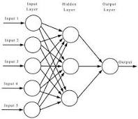

**Impacts:**

Signs of a citrate reaction include:

* [numbness](https://www.healthline.com/symptom/numbness) or tingling, especially in the lips, fingers, and toes
* feeling vibrations throughout the body
* experiencing a metallic taste
* chills
* shivering
* lightheadedness
* [muscle twitching](https://www.healthline.com/symptom/muscle-twitch)
* a rapid or slow pulse
* shortness of breath

If these symptoms are left untreated, they may become more severe. Severe symptoms include:

* spasms
* [vomiting](https://www.healthline.com/symptom/vomiting)
* [shock](https://www.healthline.com/symptom/shock)
* [irregular pulse](https://www.healthline.com/symptom/abnormal-heart-rhythms)
* [cardiac arrest](https://www.healthline.com/health/cardiac-arrest)

**Beneifts of donating plasma**

**Health assessment**

When you come in to donate, you help provide lifesaving care to patients in need. But you also receive the added benefit of a free mini-health assessment, provided by a trained Red Cross staff member.Prior to donating blood, all donors will receive a free health screening. At the time of your donation, your blood pressure, hemoglobin, and pulse will be checked. We record these vitals in your online [donor profile](https://www.redcrossblood.org/account-login.html) where you can track and monitor your results. You can access this information as well as past health information obtained during prior donations, at any time. Your online profile is a great resource to track your health goals and share with your care providers. Your health is an important part of your donor journey and key to continuing to help others in need.

**Important tables**:

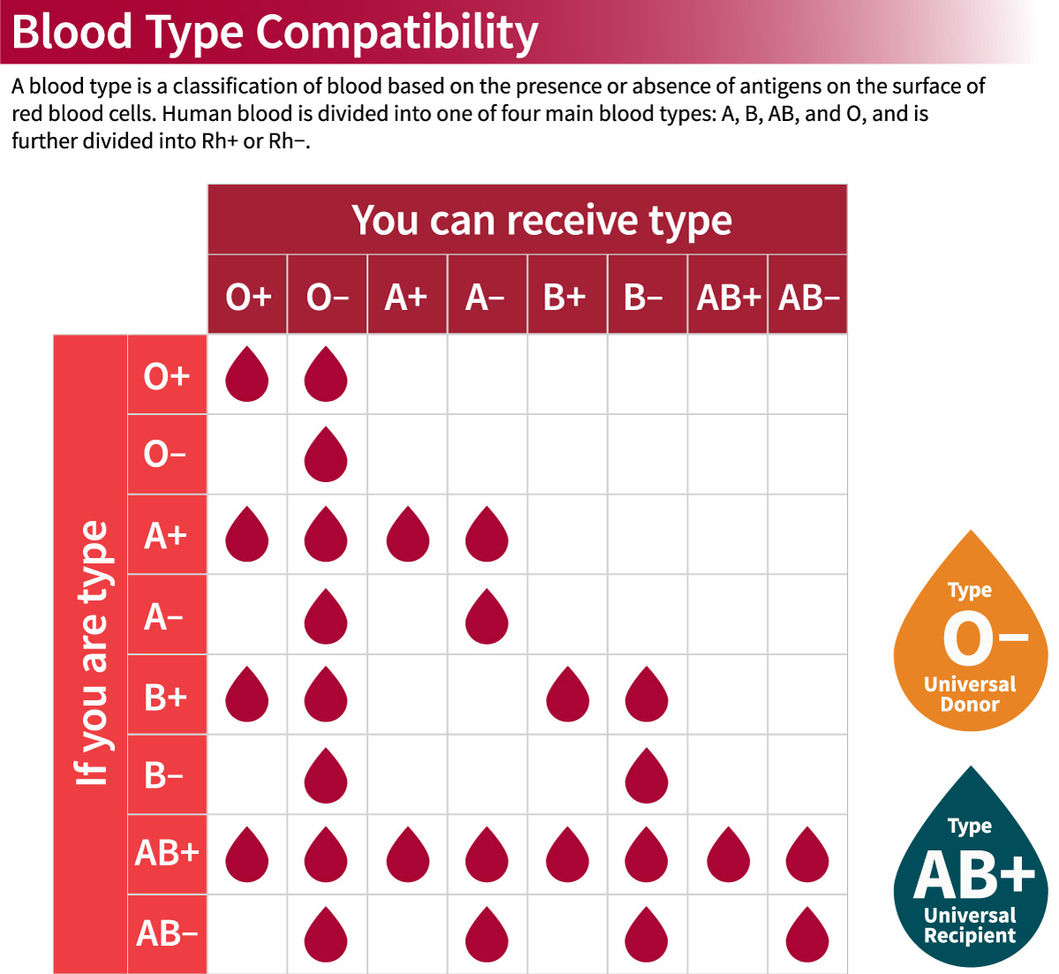

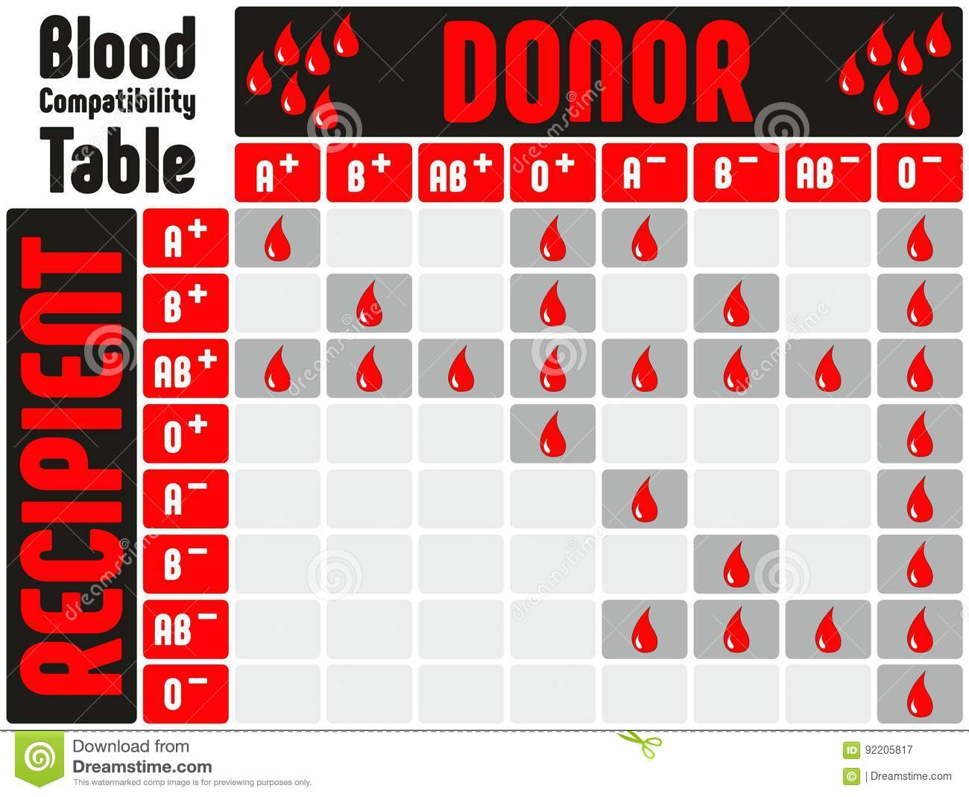

**Blood compatibility table**

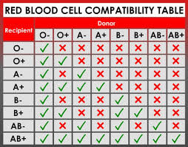

**Red blood cell compatibility table**